Game Design Document

Fill up the following document

1. Write the title of your project.

Mission Earth

1. What is the goal of the game?

To save planet earth

1. Write a brief story of your game.

**World military organisation has alloted a mission to a team of pilot to save mother earth from the asteriods.The captain decides that one pilot will fight with the asteriods after the first pilot dies than other one will go.**

1. Which are the playing characters of this game?

* Playing characters are the ones who respond to the user based on the input from the user.
* Cars, monkeys, dinos, wizards, etc., are the playing characters in the game.

|  |  |  |
| --- | --- | --- |
| Number | Character Name | What can this character do? |
| 1 | Fighter plane | Shoot missile |
| 2 |  |  |
| 3 |  |  |
| 4 |  |  |
| 5 |  |  |
| 6 |  |  |
| 7 |  |  |
| 8 |  |  |

1. Which are the Non-Playing Characters of this game?

* Non-Playing characters are the ones that don't have an action or behavior when the user interacts with the game.
* Hurdles, stones, bananas, coins, etc., are non-playing characters in the game.

|  |  |  |
| --- | --- | --- |
| Number | Character Name | What can this character do? |
| 1 | Asteriods | Trys to destroy the earth |
| 2 | Bullet | Destroys the asteriods. |
| 3 |  |  |
| 4 |  |  |
| 5 |  |  |
| 6 |  |  |
| 7 |  |  |
| 8 |  |  |

Draw your imagination of this game. What does this game look like?

* Draw the game either on your computer or on paper.
* Add images of the game scenes to show each of the playing and non-playing characters at least once.

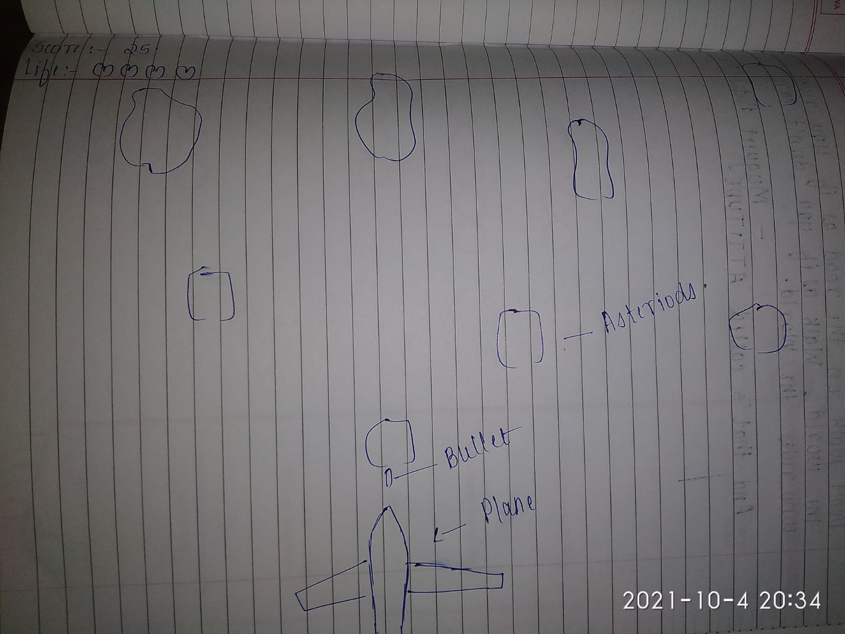

How do you plan to make your game engaging?

Will keep the difficulty level increasing.